**First Part: Test Plan for YallaKora**

**Platform:** IOS mobile application

**Release Version:** 6.13

**Test Designed by**: Mayada AlSawah

**Module:** Matches page

**Test type:** Functionality

|  |  |  |  |  |  |  |  |
| --- | --- | --- | --- | --- | --- | --- | --- |
| Test scenario | Test case ID | Test case title | Precondition | Test Steps | Expected result | Prioritization | Status (Pass/Fail) |
| Matches dropdown filter | YK_Matches_001 | Verify that categories having matches for selected day are displayed in filter |  | 1. In matches page, Open filter 2. Check categories displayed | * Categories having matches for the selected day are displayed * Categories are displayed in predefined order | High |  |
| Matches dropdown filter | YK_Matches_002 | Verify that categories not having matches for selected day are hidden in filter | Identify category(s) which has no matches on a specific day | 1. In matches page, Open filter 2. Check categories displayed | * Categories not having matches for the selected day are hidden | Medium |  |
| Day selection tabs | YK_Matches_003 | Verify that day tabs are displayed correctly according to selected day | Identify a day which has no matches | 1. In matches page, select a day 2. Check day tabs displayed | * Selected day is displayed in centre and in **bold** format * 3 preceding days are displayed * 3 consequent days are displayed | Medium |  |

|  |  |  |  |  |  |  |  |
| --- | --- | --- | --- | --- | --- | --- | --- |
| Day selection tabs | YK_Matches_004 | Verify that day is displayed when it has no matches | Identify a day which has no matches | 1. In matches page, select a day that has no matches | * Day which has no matches is displayed in day tabs * Clicking on the day opens a page with no matches | Low |  |
| Matches time and date | YK_Matches_005 | Verify that matches times are sorted correctly for selected day |  | 1. In matches page, check matches in each day are sorted correctly | * Matches are sorted by their start time ascending (earliest displayed first) | Low |  |
| Matches time and date | YK_Matches_006 | Verify that matches start time and end time are displayed according to device time zone | Identify/change the device’s time zone | 1. In matches page, check matches start time and end time according to the device time zone | * Start time and end time are displayed correctly if they are having the same time zone * Start time and end time should be converted based on the device time zone if they are having different time zone | High |  |
| Categories | YK_Matches_007 | Verify that categories are displayed according to preset order defined by admin | Preset categories order is configured | 1. In matches page, check matches categories | * Matches categories are displayed according to preset order | Medium |  |
| Categories | YK_Matches_008 | Verify that categories not having matches for selected day are hidden | Identify category(s) which has no matches on a specific day | 1. In matches page, check categories having no match for a selected day | * Categories not having matches for a selected day is hidden | Low |  |

|  |  |  |  |  |  |  |  |
| --- | --- | --- | --- | --- | --- | --- | --- |
| Ended matches | YK_Matches_009 | Verify that scores for ended matches are displayed correctly | Identify ended matches with its scores | 1. In matches page, check score of an ended match | * Scores for ended matches are displayed correctly | High |  |
| Ended matches | YK_Matches_010 | Verify that duration for ended matches are displayed correctly | Identify ended matches with their duration | 1. In matches page, check duration of a ended match | * Duration for ended matches are displayed correctly | Medium |  |
| Ended matches | YK_Matches_011 | Verify that start and end time for ended matches are hidden |  | 1. In matches page, check start and end time | * Start and end time for ended matches are hidden | Medium |  |

**Second part: Yalla Kora Defects**

**ID: 1**

**Bug title:** [IOS] News – Transfers: Video is not loaded when opening “Moe Salah” transfer update on 6 September 2023 at 1:41 PM

**Reproducible Steps:**

1. Go to News tab
2. Select Transfers “الانتقالات”
3. Scroll vertically in carrousel
4. Click on “Moe Salah” transfer update
5. Scroll down to see video

**Actual result:** Video is not loaded

**Expected result:**

Video should be loaded correctly with no errors

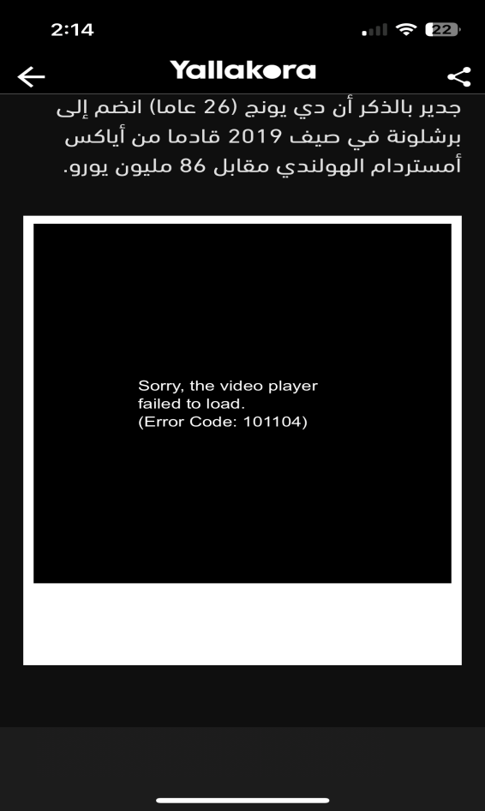**Attachments:**



**Affected Devices:** All IOS devices

**Network: 4G or Wifi**

**Severity:** Medium

**Priority:** High

**Impact:** Medium

**ID: 2**

**Bug title:** [IOS] Matches – Calendar: Unable to click on any tab in navigation tab bar while calendar is open

**Reproducible Steps:**

1. Go to Matches tab
2. Click on calendar
3. Try clicking on any tab while calendar is open

**Actual result:** Unable to click on any tab in navigation bar while calendar is open

**Expected result:** Tabs in navigation bar should be clickable when calendar is open

**Attachments:**

**  
Affected Devices:** All IOS devices

**Network: 4G or Wifi**

**Severity:** Low

**Priority:** Low

**Impact:** Low

**ID: 3**

**Bug title:** [IOS] My teams: Internet disconnected message is displayed when trying to removing the all teams

**Reproducible Steps:**

1. Go to My teams tab
2. Remove all teams

**Actual result:** Internet disconnected message appear, when removing the last team in “My teams”,

**Expected result:** All teams should be removed with no errors

**Attachments:**

**  
Affected Devices:**All IOS devices

**Network: 4G or Wifi**

**Severity:** Medium

**Priority:** High

**Impact:** Medium

**ID: 4**

**Bug title:** [IOS] Matches: Categories - “اهداف” is not displayed correctly in “ترتيب ” tab

**Reproducible Steps:**

1. Go to Matches Tab
2. Click on a category
3. In “الترتيب” tab, check the word “اهداف”

**Actual result:** Word “اهداف ” is displayed on two lines

**Expected result:** Word “اهداف ” should be displayed on one line

**Attachments:**

**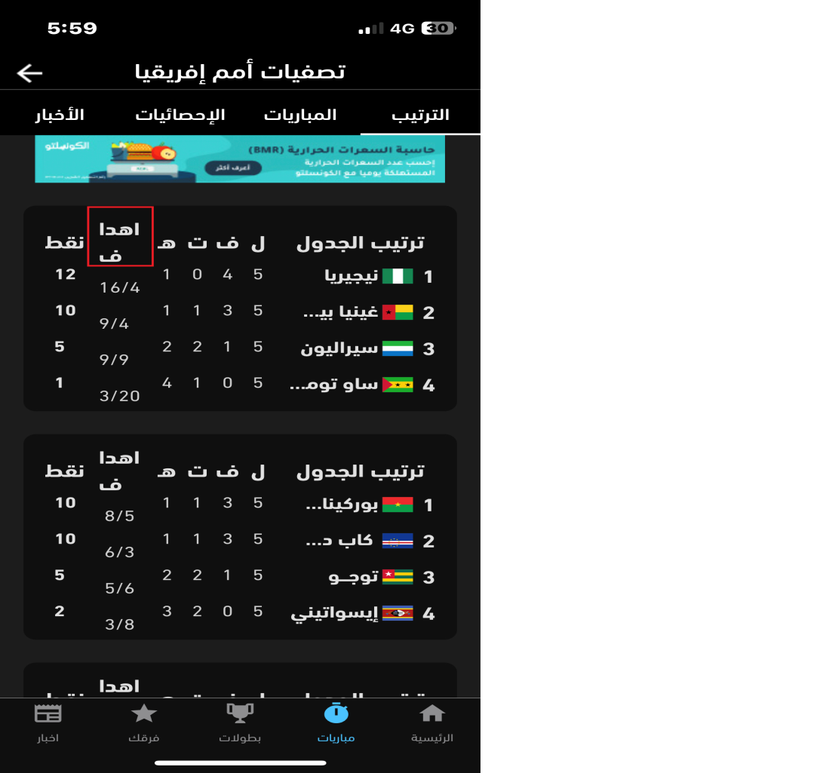  
Affected Devices:**  Iphone 13 mini & probably on all similar screen size devices)

**Network: All**

**Severity:** Low

**Priority:** Low

**Impact:** Low

**ID: 5**

**Bug title:** [IOS] Tournaments – News: Image carousel slider is not updated upon scrolling in images of image carousel

**Reproducible Steps:**

1. Go to Tournaments
2. Click on a tournament
3. Go to News tab
4. Scroll in the image carousel

**Actual result:** Image carousel slider is not updated

**Expected result:** Image carousel slider should be updated

**Attachments:**

**  
Affected Devices:** All IOS devices

**Network: All**

**Severity:** Low

**Priority:** Medium

**Impact:** Low

**ID: 6**

**Bug title:** [IOS] News – News: When using Wifi, An Image is not loaded unless news details is opened

**Reproducible Steps:**

1. Go to News
2. Go to المحترفين
3. Scroll down to news of Saturday 19th August
4. Check images of all news on this 19th August

**Actual result:** An image is not loaded unless news details of its news is opened.

**Expected result:** All images should be loaded and displayed correctly

**Attachments:**

**Affected Devices:** All IOS devices

**Network: Wifi only**

**Severity:** Low

**Priority:** Medium

**Impact:** Low